Analyzing Ethernet Cabling Standards and Pinouts

Section 7, Lecture 36

**Required Resources**

* 3' length of Category 5 or 5e cable
* 2 x RJ-45 connectors
* RJ-45 crimping tool
* Wire cutter
* Wire stripper
* Ethernet cable tester

Part 1: Analyze Ethernet Cabling Standards and Pinouts

The TIA/EIA has specified unshielded twisted pair (UTP) cabling standards for use in LAN cabling environments. TIA/EIA 568-A and 568-B stipulates the commercial cabling standards for LAN installations; these are the standards most commonly used in LAN cabling for organizations and they determine which color wire is used on each pin.

With a crossover cable, the second and third pairs on the RJ-45 connector at one end of the cable are reversed at the other end, which reverses the send and receive pairs. The cable pinouts are the 568-A standard on one end and the 568-B standard on the other end. Crossover cables are normally used to connect hubs to hubs or switches to switches, but they can also be used to directly connect two hosts to create a simple network.

With modern networking devices, a straight-through cable can often be used even when connecting like devices because of their autosensing feature. With autosensing, the interfaces detect whether the send and receive circuit pairs are correctly connected. If they are not, the interfaces reverse one end of the connection. Autosensing also alters the speed of the interfaces to match the slowest one. For example, if connecting a Gigabit Ethernet (1000 Mb/s) router interface to a Fast Ethernet (100 Mb/s) switch interface, the connection uses Fast Ethernet.  For example, the Cisco 2960 switch has autosensing turned on, by default; therefore, connecting two 2960 switches together works with either a crossover or a straight-through cable. With some older switches, this is not the case and a crossover cable must be used. With some older routers, this is not the case and a crossover cable must be used. When directly connecting two hosts, it is generally advisable to use a crossover cable.

**Step 1: Analyze diagrams and tables for the TIA/EIA 568-A standard Ethernet cable**

The following table and diagrams display the color scheme and pinouts, as well as the function of the four pairs of wires used for the 568-A standard.

*Note: In LAN installations using 100Base-T (100 Mb/s), only two pairs out of the four are used.*

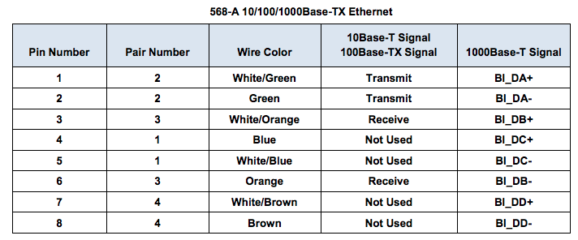

The following diagrams display how the wire color and pinouts align with an RJ-45 jack for the 568-A standard.

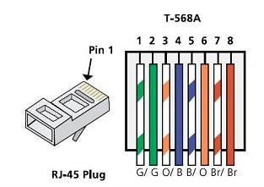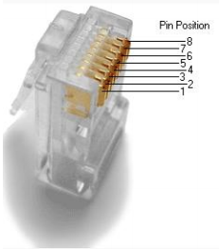

**Step 2: Analyze diagrams and tables for the TIA/EIA 568-B standard Ethernet cable**

The following table and diagram display the color scheme and pinouts for the 568-B standard.

